



**Instituto Politecnico Nacional**

**ESCOM “ESCUELA SUPERIOR DE CÓMPUTO”**

*ANÁLISIS Y DISEÑO ORIENTADO A OBJETOS*

*CU ENROLL IN UNIVERSITY – DIAGRAMA DE ACTIVIDADES*

PROFA: Reyna Melara Abarca

ALUMMNO: Rojas Alvarado Luis Enrique

CORREO: lrojase1@hotmail.com

GRUPO: 2CM9

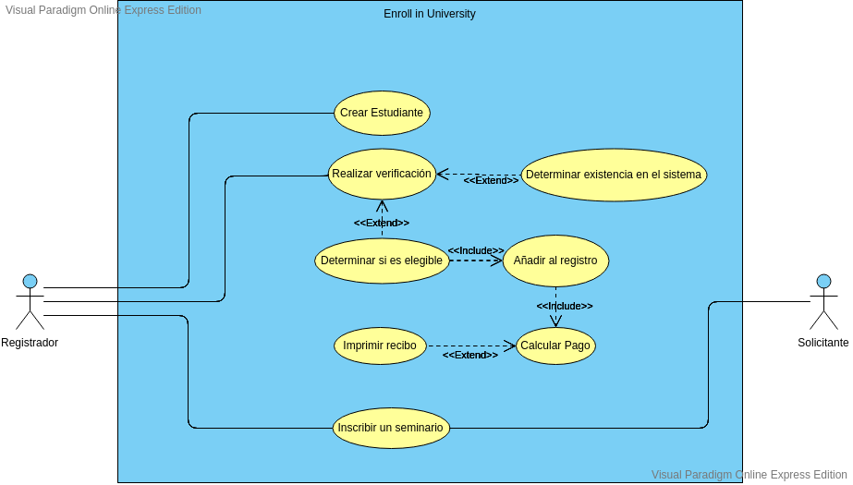

CU ENROLL IN UNIVERSITY

INTERFACES DE USUARIO

University Application Form

School of origin

Shitf to choose

Average

Name, Adress, phone number

Hometown

Print

UI13

Create student

Name

Address

Phone number

Done

UI89

Sumary

Inicial payment

+

Donation

+

Extra Payments

Total

=

Printing...

UI15

DIAGRAMA DE ACTIVIDADES

